Jeff Levine
CS499 – Mod 5 – Journal

I currently work for a biotech firm and am working on a chatbot that runs in tandem with our embedded systems technology.
“What is the significance of each trend?”
Artificial Intelligence, specifically Large Language Models (LLMs), and modern Embedded Systems are two of the most transformative technologies today. AI has completely shifted how we interact with technology, moving us from rigid, rule-based systems to natural, conversational interfaces capable of synthesis and reasoning. On the hardware side, embedded systems have evolved from simple microcontrollers into powerful, low-latency devices capable of complex Edge AI tasks. When combined, these two trends bridge the gap between physical healthcare hardware and actionable, user-friendly intelligence, making high-level technology immediate, personal, and continuous.
“How will each trend change the field of computer science?”
In computer science, LLMs are redefining software development, shifting the focus toward prompt engineering, retrieval-augmented generation, and fine-tuning specialized domain models rather than writing everything from scratch. Meanwhile, embedded systems are pushing CS to prioritize resource efficiency, real-time operating systems, and Edge computing, processing data directly on the device rather than relying strictly on the cloud. Together, they are forcing software engineering and hardware engineering to merge closer than ever, requiring developers to understand both high-level AI architecture and low-level hardware constraints.
“How will each trend change the experience of consumers, workers, or citizens?”
For consumers, the combination of embedded systems and conversational AI makes healthcare faster, safer, and infinitely more accessible. Instead of driving to a clinic, waiting for days for lab results, and trying to decipher complex medical jargon, a patient can take a blood sample right at home on an embedded testing device and immediately receive an instantaneous, accurate read out. An AI chatbot integrated into the platform can then explain those lab results in plain language, answer immediate follow-up questions, and guide the patient on next steps. It transforms passive patients into informed, proactive managers of their own health.
“How will each trend fit in with your career interests or aspirations?”
These trends line up perfectly with my current work and future career goals in medical technology and software engineering. Right now, I'm working directly with LLM models to build a custom chatbot that pairs with our proprietary embedded blood-testing product. Even though our chatbot is still in its infancy, the roadmap and planned applications are huge. Being able to connect low-level medical hardware with intelligent, empathetic user interfaces is exactly where I want to focus my career, as it allows me to build real-world software that directly improves people's lives.
“Which course outcomes have you achieved so far, and which ones remain?”
I have completed all of my proposed enhancements and added in a few additional behavioral UX features such as hiding elements based on login status or permissions.

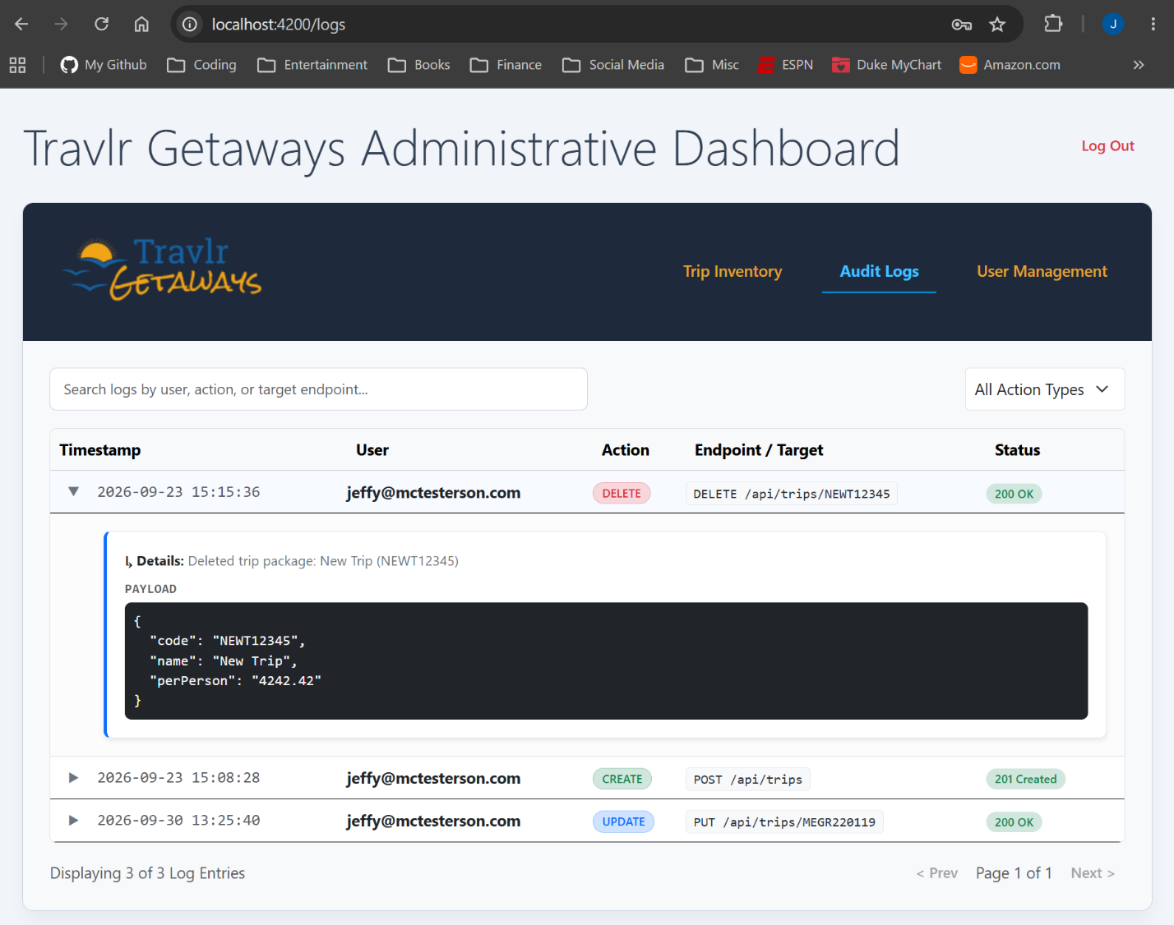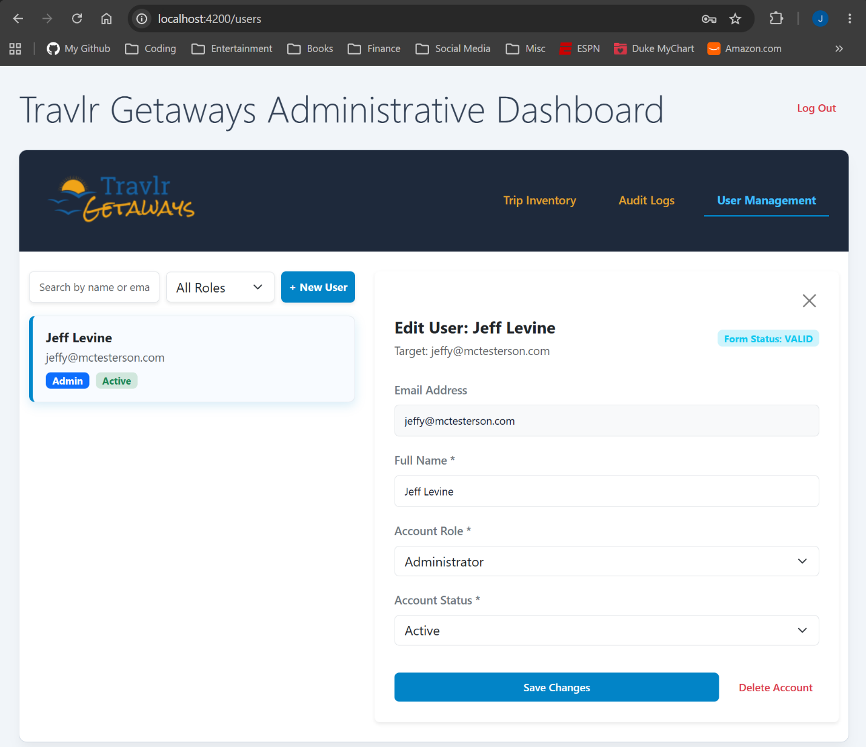
Status Checkpoints for All Categories
Checkpoint | Software Design and Engineering | Algorithms and Data Structures | Databases
Name of Artifact Used | Travlr Getaways | Travlr Getaways | Travlr Getaways
Status of Initial Enhancement | Complete | Complete | Complete
Submission Status | Submitted | Submitted | Submitted
Status of Final Enhancement | Ongoing | Ongoing | Ongoing
Uploaded to ePortfolio | Yes | Yes | Yes
Status of Finalized ePortfolio | Ongoing | Ongoing | Ongoing

https://github.com/jlevine84/cs499-eportfolio

